Assignment 3

Vedant Agrawal

19BCY10057

Develop a code to upload the water tank level and light intensity values to the IBM IoT platform and visualize them in the web application.

Procedure:

- Open Watson IoT Platform from Services in IBM Cloud. Create a new Simulation on a existing/new Device.
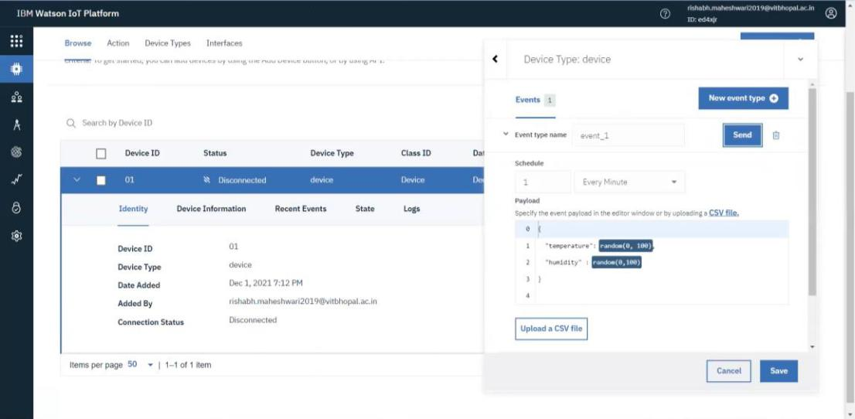

- To verify that the service is running Run the service manually and check the output in Recent Events.
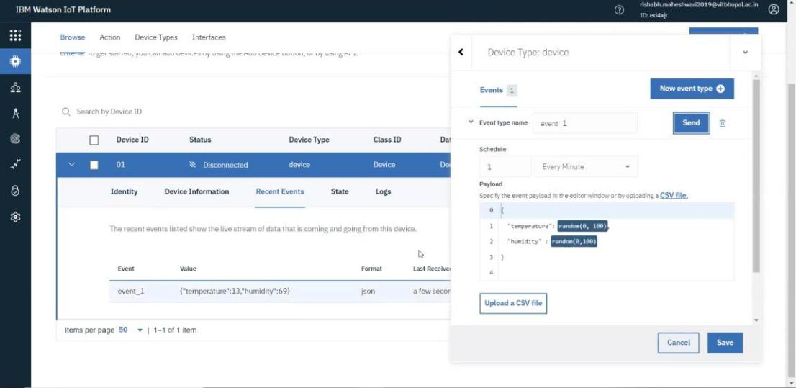

- Launch Node-RED app and add an Input pallet, You should see an ERROR message on the Debug console as shown below.
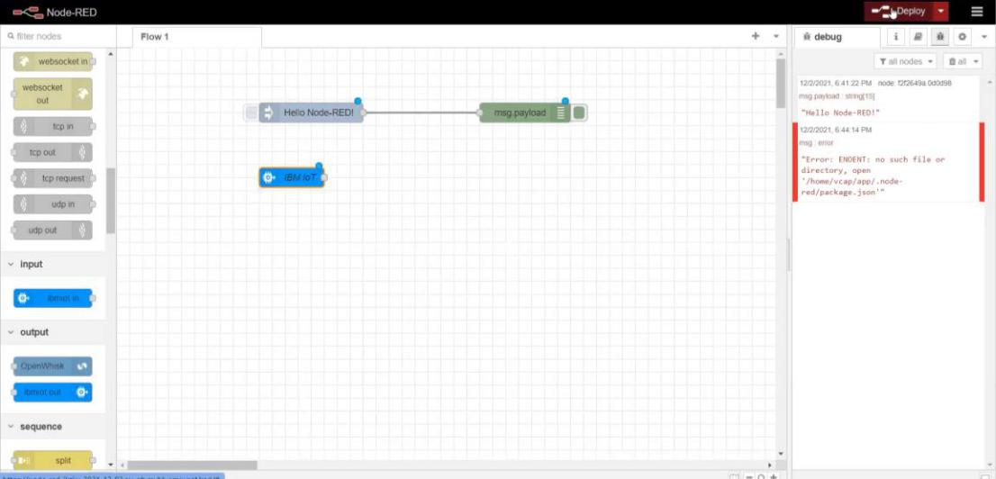

4. Edit the JSON data in the Watson IoT Platform.
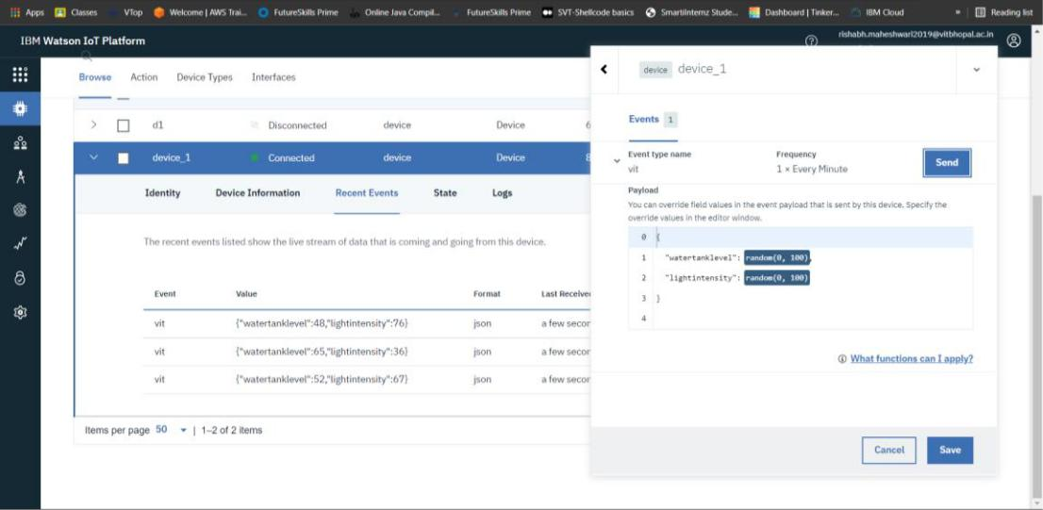

- Configure the INPUT pallet. Add the details related to your Watson IoT Platform along with the API key generated on the same.
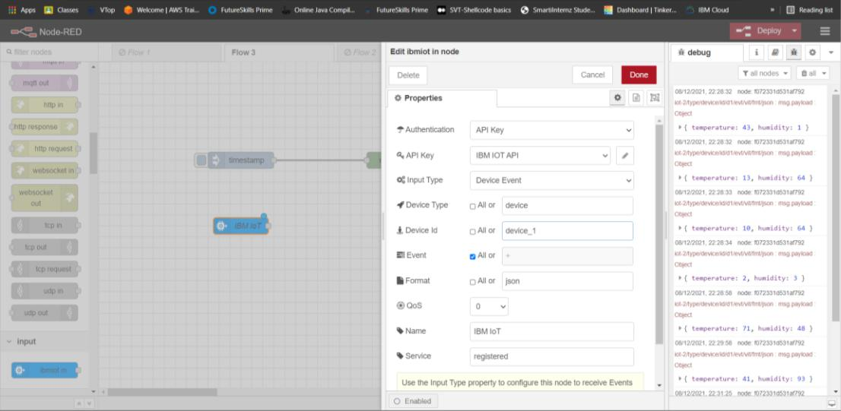

- After adding the message payload pallet the output should also be visible on the debug console of Node-RED platform.
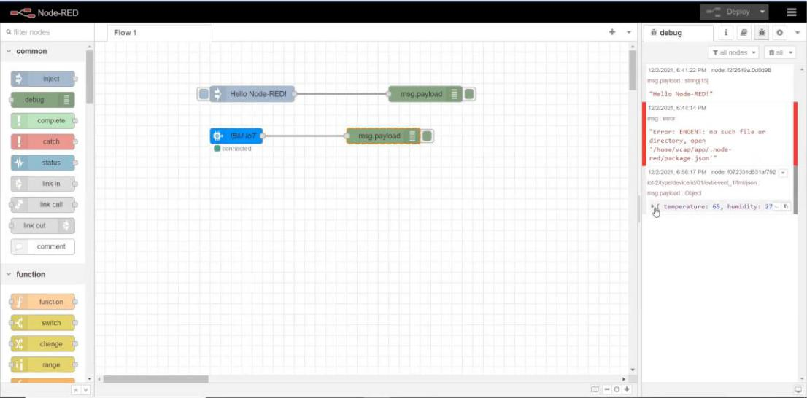

- Before executing our code we need to install wiotp.sdk module using the command

pip install wiotp-sdk.
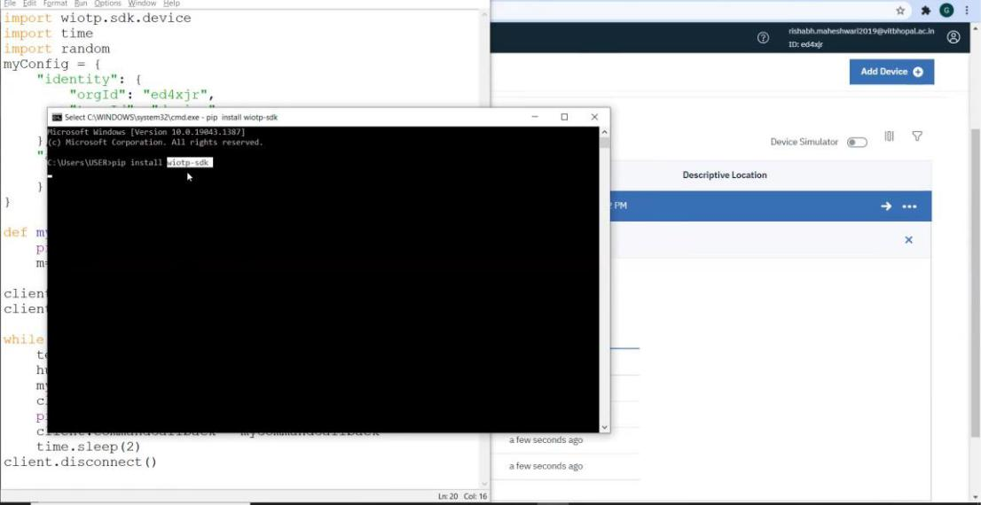

- Now for sending the data by using Python IDLE, we execute the program code so that the program starts sending data to the IBM Watson Iot Platform.

This data id further sent to the Node-RED service amd is visible on the debug console in JSON format.
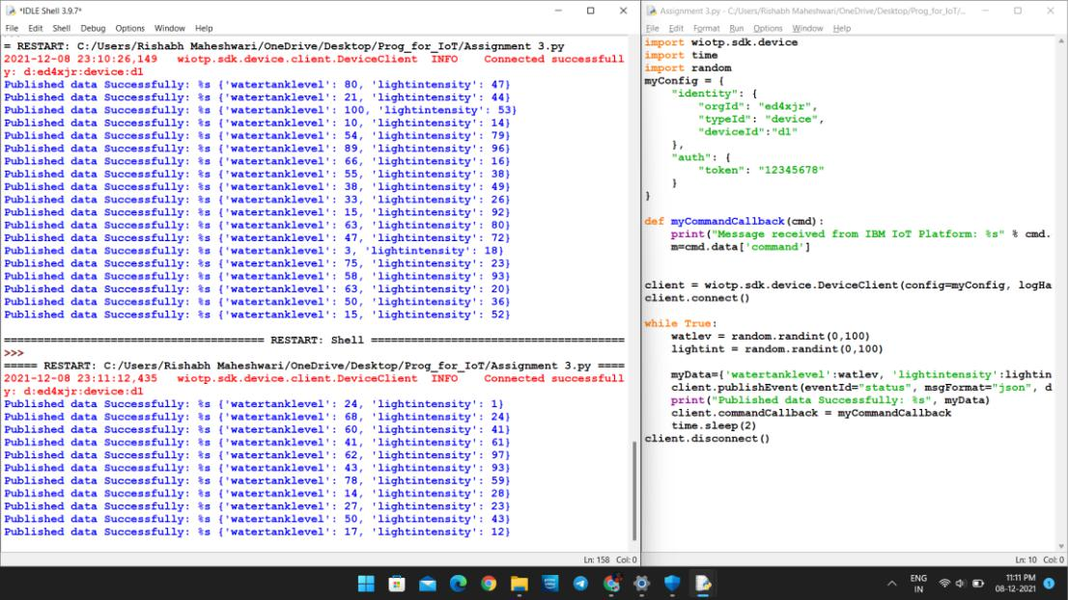

- Now add the function and dashboard pallets to the flow. Configure them using the correct IDs’. Hence, the data will be available in Readable format.
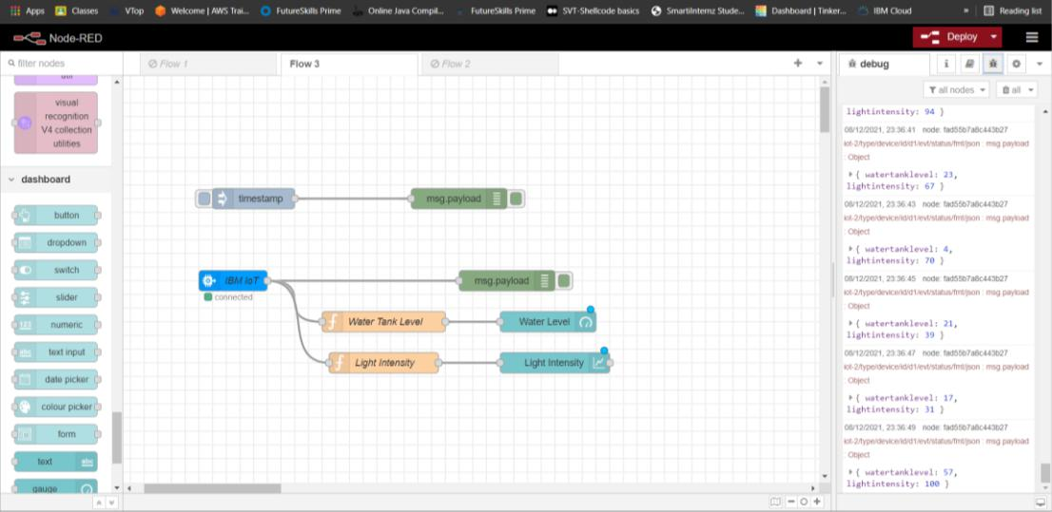

- To visualize the data in application such as chrome, just copy the Node-RED link till .net and paste the url appended by /ui in search bar. The visualization can be depicted as shown below.
